IRISH ANGUS YDP YOUNGSTOCK PERSON OF THE YEAR
CHAMPION – LIAM FARRELL, BALLINWING, LEITRIM PO, LEITRIM
NAME – MONG CHAMP 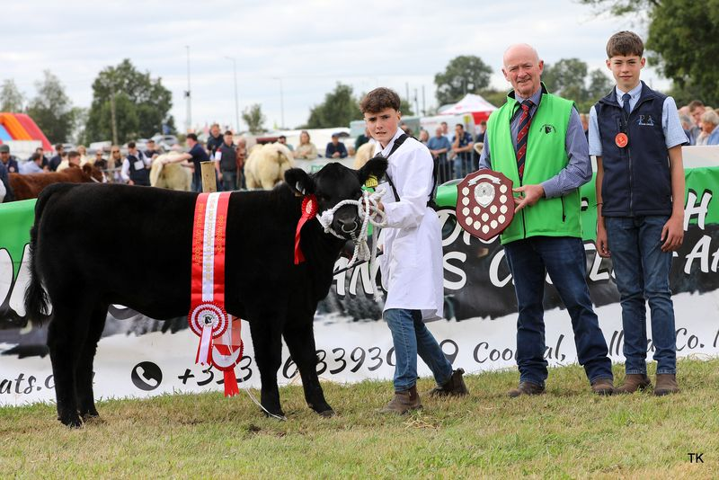
2ND PLACE – KENNETH BAILEY
3RD PLACE – RYAN FAUGHNAN
4TH PLACE – KENNETH BAILEY
5TH PLACE – LIAM WALSH

Class A – Irish Angus Bull Calf Born from January 1st 2026 to February 28th 2026

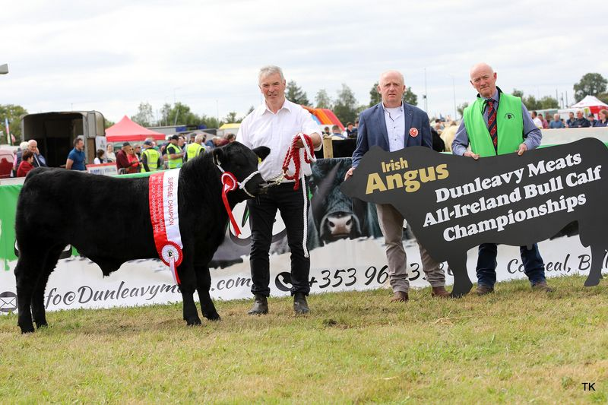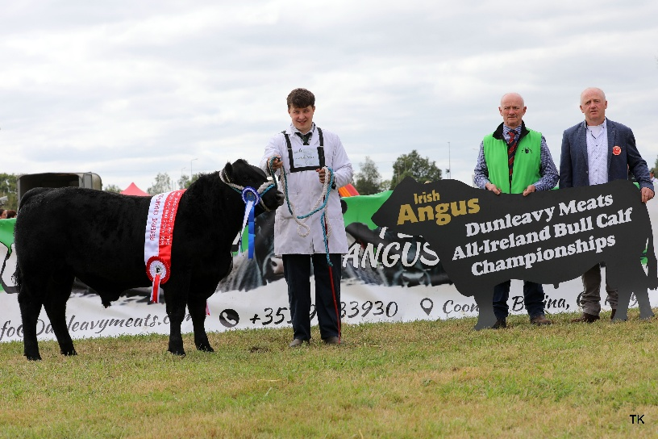
Exhibitor: Amanda Bogan & Conor Craig, Coolarty, Edgeworthstown, Co. Longford
Name: Millbawn Captain
D.O.B: 04.01.2026
RESERVE CHAMPION

Exhibitor: Patrick Regan, Cloonmore, Ballyfarna, Claremorris, Co. Mayo
Name: Loughglynn Celtic Warrior
D.O.B: 04.02.2026
CHAMPION
3RD PLACE – KENNETH BAILEY, LISMURTAGH, TULSK, CASTLEREA, ROSCOMMON
NAME - LISMURTAGH CHIEF
4TH PLACE – BRIAN FAUGHNAN, CLOONCARNE, BORNACOOLA, LEITRIM
NAME - MOLLOY CODY
5TH PLAE AMANDA BOGAN & CONOR CRAIG, COOLARTY, EDGEWORTHSTOWN, LONGFORD
NAME – MILLBAWN COMMANDER
6TH PLACE – JOE FARRELL, BALLINWING, LEITRIM P O, LEITRIM
NAME – MONG CHAMP
7TH PLACE – CATHAL MCCORMACK, STEIL, TULSK, CASTLEREA, ROSCOMMON
NAME – STEIL COMEDIAN

CLASS B – IRISH ANGUS BULL CALF BORN FROM MARCH 1ST 2026 TO APRIL 30TH 2026
Exhibitor: PJ Kenny, Liscahill, Mostrim, Co. Longford
Name: Mostrim chief
D.O.B: 18.03.2026
CHAMPION

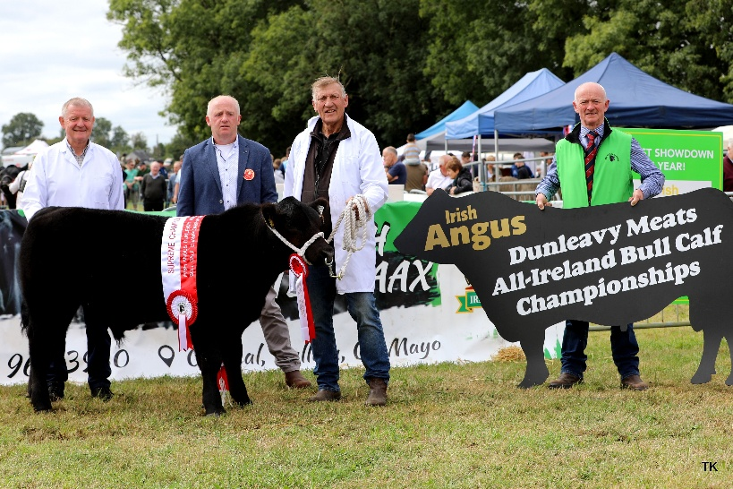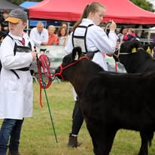
Exhibitor: Ryan Faughnan, Lisdadnan, Mohill Co. Leitrim
Name: Lisdadnan Crown
D.O.B: 24.04.2026
RESERVE CHAMPION

3RD PLACE -AIDEN & DAVID REYNOLDS, BUNLAHY, BALLINALEE, LONGFORD
NAME – BUNLAHY CRACKER JACK
4TH PLACE – HELEN FAUGHNAN, LISDADNAN, MOHILL, LEITRIM
NAME – STEIL CARTER
5TH PLACE – CATHAL MCCORMACK, STEIL, TULSK, CASTLEREA, ROSCOMMON
NAME – STEIL CLUBMAN
6TH PLACE – THOMAS MULLIGAN, CURRYCAMP, DROMOD, LEITRIM
NAME - CLOONCARNE CAMON
7TH PLACE - THOMAS MULLIGAN, CURRYCRAMP, DROMOD, LEITRIM
NAME – CLOONCARNE CR 7

CLASS C – IRISH ANGUS BULL CALF BORN FROM NOVEMBER 1ST 2025 TO DECEMBER 31ST 2025
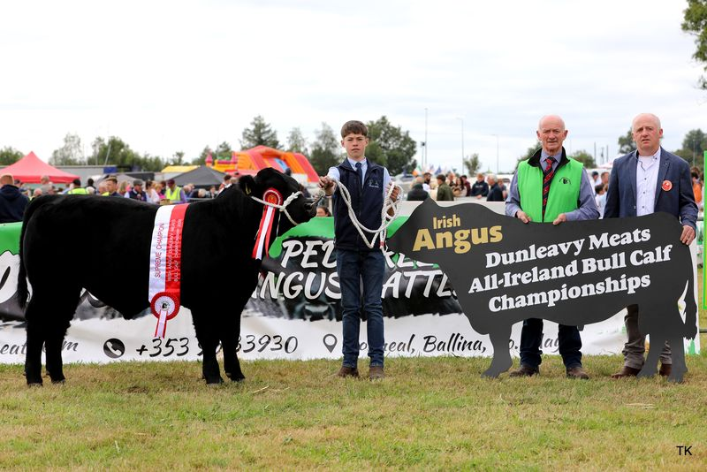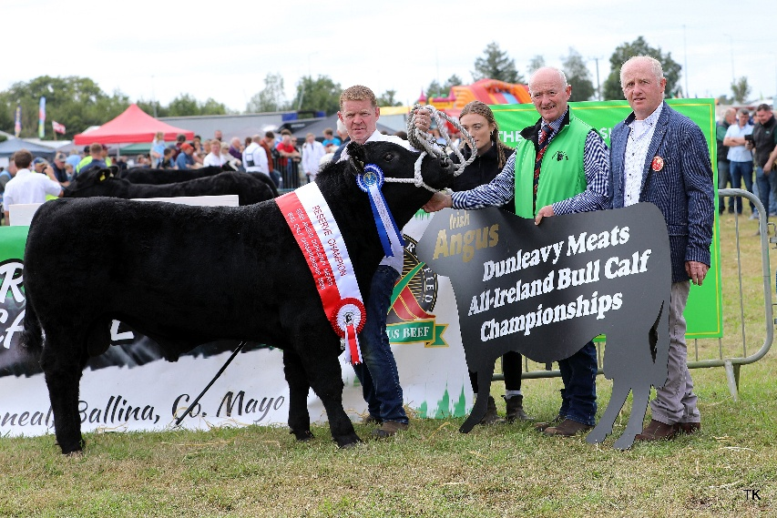
Exhibitor: Michael Doorley, Cloonmurray, Strokestown, Co. Roscommon
Name: Rawburn Boss Hogg N630
D.O.B: 02.11.2025
RESERVE CHAMPION

Exhibitor: Kieran Ryan, Castleblagh, Ballyhooly, Co. Cork
Name: Ryans Buster
D.O.B: 02.11.2025
CHAMPION

3RD PLACE – JOSEPH MCGARRY, CALDRA, NEWTOWNFORBES, LONGFORD
NAME - CLONGUISH BUSTER
4TH PLACE – AIDEN & DAVID REYNOLDS, BUNLAHY, BALLINALEE, LONGFORD
NAME – BUNLAHY BON JOVI
5TH PLACE – NIALL REGAN, GORTHAGANNY, CASTLEREA, ROSCOMMON
NAME – CONEYISLAND BUSTER
6TH PLACE – JAMES KELLY, MOUNT BALLYNACALLY, CLARE
NAME – MOUNT BENTLEY
7TH PLACE – GERARD REGAN, DRINEY, LOUGHGLYNN, CASTLEREA, ROSCOMMON
NAME – DRINEY BANG

Class D – Irish Angus Bull Calf Born From August 1st 2025 to October 31st 2025

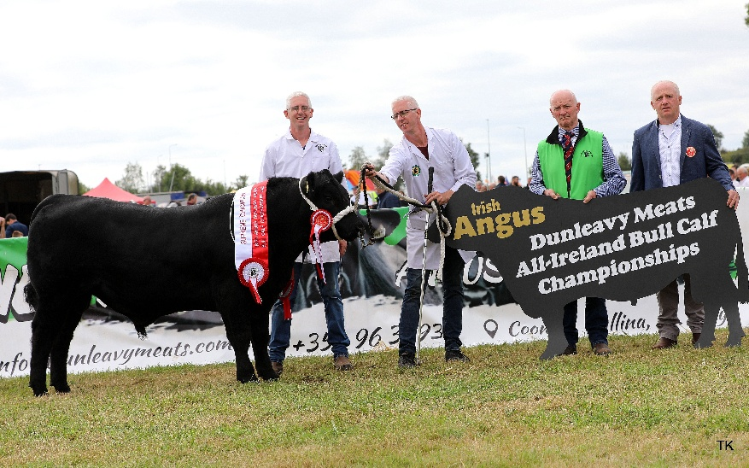
Exhibitor: Eunan Boyce, Quignalegan, Sligo Road, Ballina, Co. Mayo
Name: Quignalegan Bert 669
D.O.B: 15.09.2025
RESERVE CHAMPION

Exhibitor: Aidan and David Reynolds, Bunlahy, Ballinalee Co. Longford
Name: Bunlahy Bobby
D.O.B: 20.09.2025
CHAMPION

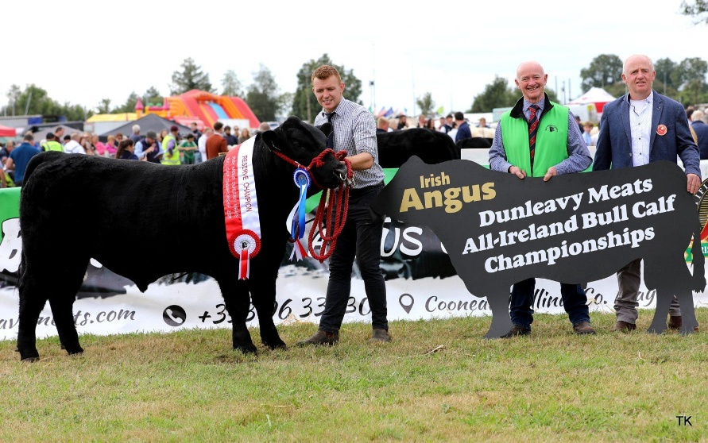
3RD PLACE – JOHN G BARLOW, GURTAVOHER, WEST AHERLOW, TIPPERARY
NAME – GORTAVOHER VENICE
4TH PLACE – THOMAS MULLIGAN, CURRYCRAMP, DROMOD, LEITRIM
NAME – CLOONCARNE BONANZA ET
5TH PLACE – THOMAS MULLIGAN, CURRYCRAMP, DROMOD, LEITRIM
NAME – CLOONCARNE BEAR ET
6TH PLACE – ALAN GIBBONS, COGGLE, STROKESTOWN, ROSCOMMON
NAME – CARROWBOY BUSTER 97
7th place – JOHN G BARLOW, GURTAVOHER, WEST AHERLOW, TIPPERARY
NAME – GURTAVOHER BLACK EAGLE

